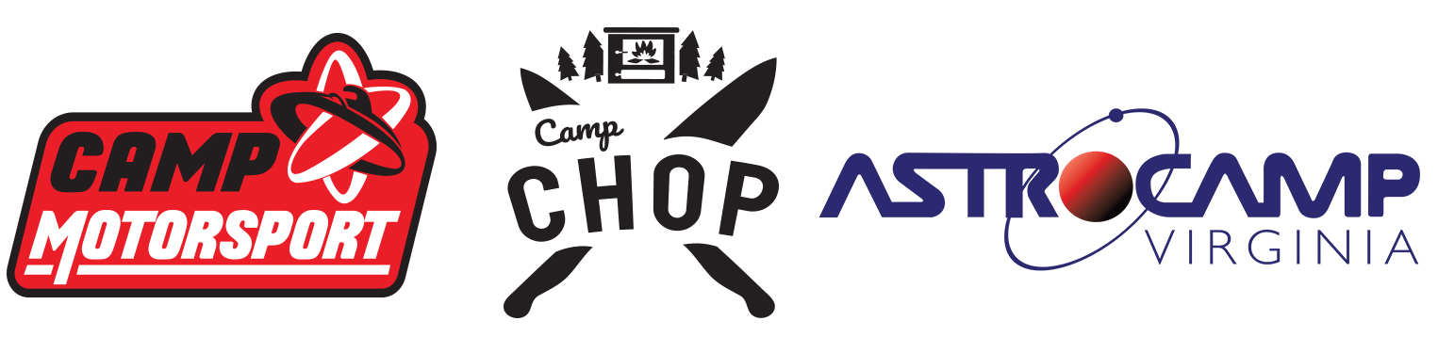
FAQ’s FOR COUNSELORS

1. What are you doing with regards to COVID-19?
As I am sure you can imagine, this question has a long, and complex answer (we could probably write a FAQ about it!). The short version is, we are following whatever National/State guidelines we are given. Further to that, the American Camp Association has created a safe operation field guide to help summer camps navigate day-to-day operations during the pandemic. If you have any questions or concerns, please email john@gdi.org.

2. Can I make/receive phone calls?
Yes. You may make calls from the office (important only) or use your cell phone (designated areas). We ask that counselors DO NOT make phone calls during the workday or when you are in charge of campers. You may also receive EMERGENCY (or EXTREMELY important) calls on our business line; the number is (434) 454-4059. Do not give this number out to friends!

3. Do I have access to the Internet?
We do have limited wireless internet access. You are more than welcome to bring your laptop computer. We ask that you not use the internet in the dorms or in view of campers. After hours it’s common to use the Staff Lounge when you are not in charge of campers. We also ask that you never share your computer or internet access with campers – they are to be completely unplugged while they are at camp. Our internet is not fantastic. It is usually enough to check emails, Facebook, etc. It cannot handle any kind of streaming.

4. Are there laundry facilities I can use?
Yes. There are free laundry facilities for you to use. You will need to supply your own detergent, which can be purchased in town during our time-off or online.

5. How isolated is camp? Is there somewhere nearby where I can buy toiletries, personal items, etc.?
Our camp is located near the very small town of Clover, where there is little more than a post office and a stop sign. The nearest town is South Boston (30min drive) where there is a Walmart and drug stores to purchase essentials.

6. Can I receive and send mail regularly?
Yes. You can have mail sent directly to camp. We receive USPS, FedEx and UPS. It will be delivered to the front office and be distributed via the Staff Lounge daily.
Our address is:
Your Name
Astrocamp, Camp Motorsport & Camp CHOP
8144 Mount Laurel Road
Clover VA, 24534

7. What is the weather typically like?
Summer days in Virginia are generally hot and humid, generally around 70-88F. Summer rainstorms are a VERY common thing. Though they pass relatively quickly, the rain is normally heavy. We recommend a lightweight rain jacket as it will still be humid.

8. Can I have friends and family visit camp?
Unfortunately, we cannot allow summer staff to have visitors on camp property at any time. This is part of our safety and security promise that we make to camp families.

9. Do I get any time off during summer?
Yes! At the end of each camp session you will get a little under 24hrs off (11am Saturday until 10am Sunday) and once every 2 weeks you will be assigned a full 24 hours off (noon-noon) with other counselors & Instructors.

10. What’s the best time for me to exercise?
Before you wake up your campers at 7 AM is the best, or at night after they’re asleep. Please allow yourself enough to be ready for the day. We have a small, primitive gym on-site with some basic weights and equipment that you are welcome to use.

11. What does Staff Training involve?
Staff Training consists of setting up the camp, learning the in’s and out’s of working with children aged 8-17, how to best protect them and the legal stuff surrounding working with them, learning the daily camp routine (including activities and evening events, etc.), and bonding with other staff members.

12. Do I have to be Lifeguard, First Aid or CPR certified?
You will be asked to attempt the Red Cross Lifeguarding Certification. You do NOT need to pass but we ask that you attempt the course. First Aid and CPR are great tools to have in your back pocket and you will be provided with this certification at no cost. All staff will become First Aid & CPR certified.

13. Is there a dress code?
Yes and no. We do not require that you wear a uniform, but we ask that you dress modestly and appropriately and please practice good cleanliness and personal hygiene. What modestly means is no thong or cheeky bikinis, no Speedos; and please limit the use of low-rise pants, short-shorts, midriff baring or low-cut t-shirts. Please keep in mind you are around teenagers all summer, so please dress modestly so not to draw any undue attention to your body. Campers will push the limits, but we as the role models should set a modest tone. When we say appropriately, we mean that you are not to wear any clothing advertising an alcoholic beverage, tobacco, drug usage, profane, political or religious slogans. Please use your judgment.

If you have any other questions, please email john@gdi.org

